Content Maximizer

User Guide

Table of contents:

1. Introduction

2. Installation Steps

3. Getting into the Admin area

4. Using Content Maximizer

1 INTRODUCTION

This document is a detailed guide for using the “Content Maximizer” script. Instructions for every option inside the script are located in appropriate sections of this document.

2 INSTALLATION STEPS

In order to begin installing My Ad Rotator, the contents of the folder should be uploaded to your web site.

2.1 Downloading Smarty 2.6.13

Go to the following link and download Smarty 2.6.13

http://smarty.php.net/download.php

NOTE: The smarty download is in a Linux/Unix compressed format called .tar. You should be able to download it and unzip it with your regular zip tool. If you are unable to do this we recommend the free WinRar compression tool:

http://www.rarlabs.com/download.htm

2.2 Uploading Smarty

After you have downloaded and extracted Smarty, you will need to upload the contents to the web server of your intended install. When you do this make sure that you make a note of the path to the Smarty folder. Example:

/home/web/mysite/htdocs/smarty/

2.3 Testing and Installing Smarty

You will need to grant write permissions (777) to the following file:

/smarty2/demo/templates_c

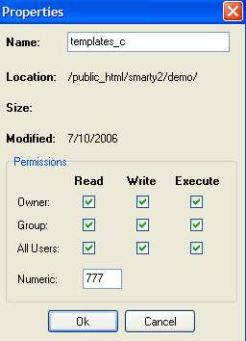

You will now need to test the Smarty engine by going to the /demo/index.php file

When you go there you should see a screen like this:

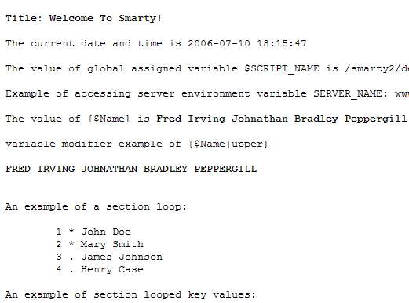

2.4 Setting up a MySQL database

Using your assigned cPanel or DirectAdmin set up a new database and username, which you can easily remember. Make sure that the database user has permissions to all functions for the database. It may be useful to assign the database name the same as your folder name and the user and password something that you easily remember.

2.5 Granting permissions for Content Maximizer

You will need to grant 777 permissions to the following files:

/ini/msql-u.php

/templates_c

/admin/templates_c

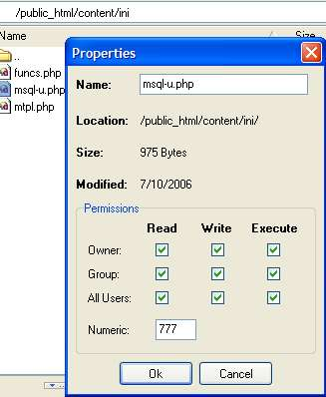

2.7 The installer

Go to the installer by going to http://www.yourdomain.com/foldername/install/index.php

You will then be prompted to enter the following information:

DB Host Name
DB Name
DB Username
DB Password
Site Path
Full Smarty.class.php server directory path
Web access base url
Web access subfolder
Send email from

The DB Host Name is the usually ‘localhost’ or and assigned IP address given to the database by the server. In most cases when you set up the database in your cPanel, information will be displayed as to what the hostname is.

DB Name is the name that you gave the new database when you created it.

DB Username is the username that you assigned to the database.

DB Password is the password you selected for the username of the database.

Full Smarty.class.php server directory path: For example:

/home/user/public_html/foldername

Web access base url is the URL that the script resides. For example:

http://www.yoursite.com

Web access subfolder is the full path that will be used for the script to recall the snippets. For example:

home/user/public_html

NOTE: Notice the above does not have the ‘/’ before home and nor after public_html

Send email from is the email that will be displayed when new user registration information is emailed to the user.

This is an example of a properly filled out installation screen:

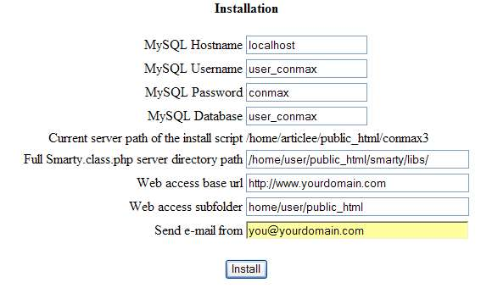

2.6: Finishing the installation

Press the ‘Install” button.

Congratulations! You have installed Content Maximizer.

If you get an error message please check your settings and try again.

2.7 Uploading an .htaccess file

If you are going to display the PHP content inside of your .html pages you will need to make sure that you have an .htaccess file.

You need to determine whether you already have a .htaccess file in your websites root. If you do, download it to your local computer using your FTP software, and then open it with Notepad.

Look to see if this line exists in your .htaccess file:
AddType application/x-httpd-php htm html
If it does not, add it to the top of your .htaccess file, save that file, and upload it back up to your webserver.

3 GETTING INTO THE ADMIN AREA

To access the Content Maximizer admin area go to:

http://www.yourdomain.com/foldername/admin/index.php

The default username and password are:

User: admin
Pass: admin

Below is what the admin user interface looks like:
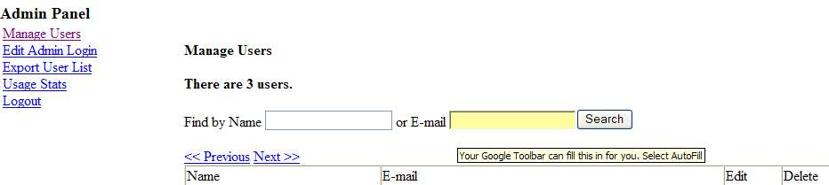

In the admin area you will be able to add/remove users, export user lists, and view usage stats.

In the Manage Users section you will be able to Edit/Delete users as well as search for them by name or email.

Export User List will automatically export all users information in .csv format.

Usage Stats are also available in the admin area. Click on the option to see user usage stats in KB amounts.

To perform any of these task click on the option on the left side of the admin panel.

4 USING CONTENT MAXIMIZER

4.1 Register

Content Maximizer was created to be used as a membership site. Since this is the case there are 3 main areas that you will be accessing to use this script:

Register
Members
Admin (covered in section 3)

The first thing that will be necessary is for you to add yourself as a member so you can use the script. To do this go to:

http://www.yoursite.com/foldername/register.php

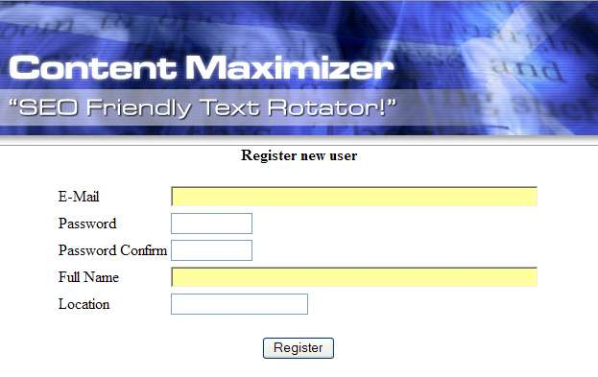

You can fill in the form and click when done.

You are now a registered user for the script and are ready to use it.

NOTE: If you are going to sell memberships it may be a good idea to make the register page a little less obvious. If you want to do this you will need to do 2 things:

- You will need to rename /foldername/register.php to something less obvious. For example you could rename it to: /foldername/reg171.php

- Open the file /foldername/templates/register.tpl in your HTML editor. You will then need to rename register.php on line 70 to the name that you changed your registration page name to.

The Members area

To get to the members area go to:

http://www.yoursite.com/foldername/members.php

NOTE: If you are going to sell memberships to use this script there is no limit to the number of users that you can have.

Once inside you will have the following options:

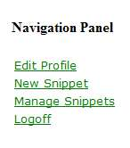
In the members area you will be able to create snippets for use on your pages.

To start creating your snippets click New Snippet.

Below is an example of the proper way to create a snippet:
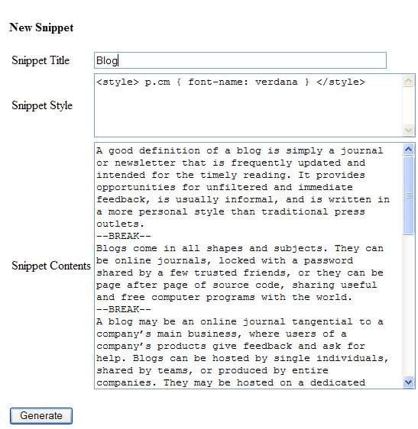

Notice the separator token code ( --BREAK-- ). You will need to insert this where you want the text snippets to begin and end.

4.3 Inserting the snippet to your pages

Inside the members area you will see a button to Manage Snippets. Once you select one of the snippets that you have created click on Show Code:

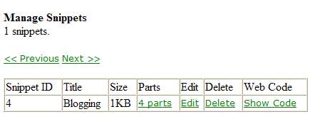

You can also see how many parts there are in your selected snippet, edit the snippet, and delete it.

When you select Show Code the following is what will be displayed:

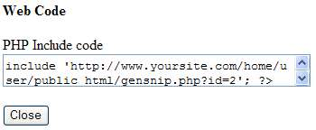

You will need to copy the include code and then paste it in the page that you want it to appear where you want it to appear.

You may create and use as many snippets as you like.

Enjoy Content Maximizer!

